**Practical No. 1**

**Aim:**

Study of logic gates (AND, OR, NOT, NAND, NOR, Ex­OR).

**Apparatus:**

connecting wires, power supply, bread board, ICs as follow

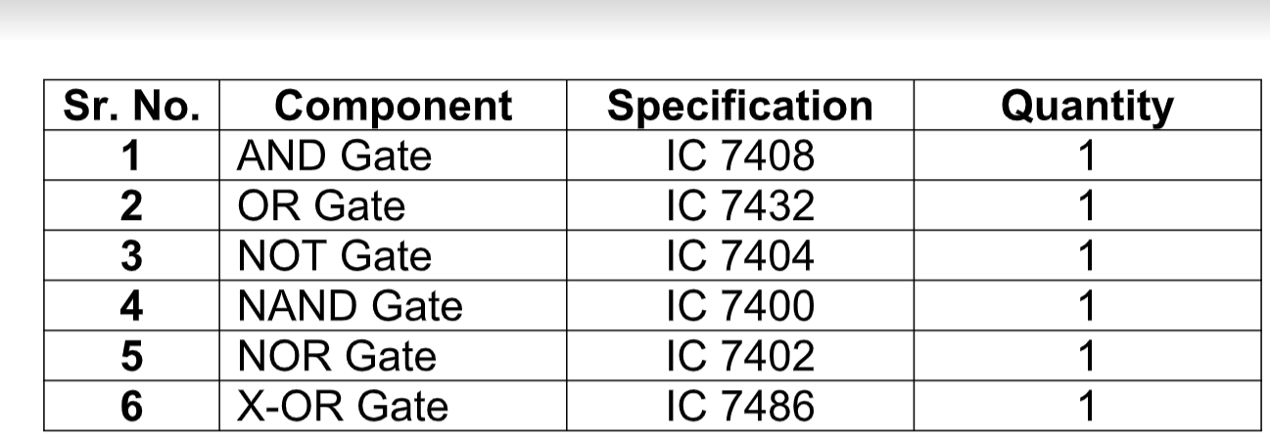

**Theory:**

Circuit that takes the logical decision and the process are called logic gates. Each gate has one or more input and only one output. OR, AND &amp; NOT are basic gates. NAND, NOR, XOR are known as universal gates. Basic gates can be obtained from all this gate.

**AND Gate:**

The AND gate performs a logical multiplication commonly known as AND

function. The output is high only when both the input are either one high or one low.

When both the input are high the output is low level.

**SYMBOL:**

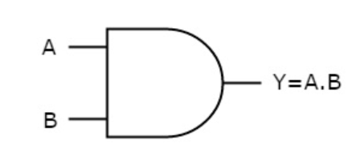

**Observation Table:**

|  |  |  |
| --- | --- | --- |
| INPUT | INPUT | OUTPUT |
| 0 | 0 | 0 |
| 0 | 1 | 0 |
| 1 | 0 | 0 |
| 1 | 1 | 1 |

**OR Gate:**

The OR gate performs a logical addition commonly known as OR function.

The output is high when any one of the inputs is high and the output is low level

when both the inputs are low.

**Symbol:**

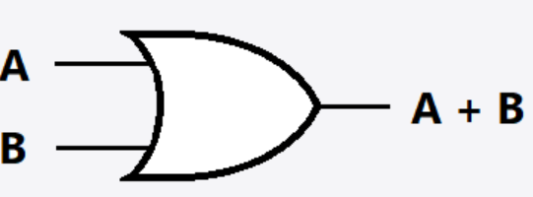

**Observation Table:**

|  |  |  |
| --- | --- | --- |
| INPUT | INPUT | OUTPUT |
| 0 | 0 | 0 |
| 0 | 1 | 1 |
| 1 | 0 | 1 |
| 1 | 1 | 1 |

**NOT Gate:**

The NOT gate is called an inverter. The output is high when the input is low. The output

is low when the input is high.

**Symbol:**

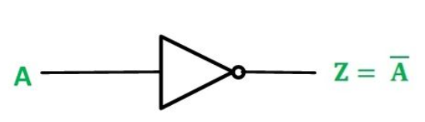

**Observation Table:**

|  |  |
| --- | --- |
| INPUT | OUTPUT |
| 0 | 1 |
| 1 | 0 |

**NAND Gate:**

The NAND gate is a contraction of AND­NOT. The output is high when both inputs

are low and any one of the input is low. The output is low level when the input are high.

**Symbol:**

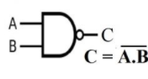

**Observation Table:**

|  |  |  |
| --- | --- | --- |
| INPUT | INPUT | OUTPUT |
| 0 | 0 | 1 |
| 0 | 1 | 1 |
| 1 | 0 | 1 |
| 1 | 1 | 0 |

**NOR Gate**

The NOR gate is contraction of OR­NOT. The output is high when both inputs

are low. The output is low when one or both inputs are high.

**Symbol:**

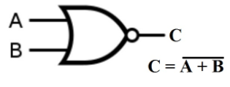

**Observation Table:**

|  |  |  |
| --- | --- | --- |
| INPUT | INPUT | OUTPUT |
| 0 | 0 | 1 |
| 0 | 1 | 0 |
| 1 | 0 | 0 |
| 1 | 1 | 0 |

**X­OR Gate:**

The output is high when any one of the input is high. The output is also low when

both the inputs are low and both inputs are high.

**Symbol:**

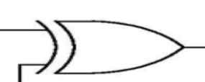

**OBSERVATION:**

|  |  |  |
| --- | --- | --- |
| INPUT | INPUT | OUTPUT |
|  |  |  |
| 0 | 0 | 0 |
| 0 | 1 | 1 |
| 1 | 0 | 1 |
| 1 | 1 | 0 |

**CONCLUSION:**

By studying the above practical , we learned characteristics of many LOGIC gates of DIGITAL ELECTRONICS.